3GPP TSG-RAN WG1 Meeting #125 R1-2603737
Dalian, China, May 18th – 22nd, 2026

Agenda Item: 10.8.2
Source: Tejas Networks
Title: Discussion on Aspects of Integration of Sensing with Communication for 6G
Document for: Discussion and Decision

Introduction

Plan for RAN1 #125
Based on the agreements made in RAN1#124bis, let’s parallelly identify other issues for study and elaborate the study on RS design and measurement/report. Note: Since we are in study phase, please focus on key design choices with proper justification.
- Usage scenarios for sensing assisted communication.
Note: this doesn’t mean we want to directly specify anything. We need RAN1 views on communication assistance which is required by RAN. To justify a usage scenario, either evaluation (10.8.1) or analysis can be considered.
Note: after clarification on the usage scenarios, it is possible that they are merged with object detection/tracking in respective discussions.
- RS design
  - Please elaborate designs on sensing RS especially the RE patterns.
  - Please provide evaluations/analysis.
- Measurement/report
  - Measurement definitions/levels for TRP-side and UE-side measurements, taking into account the impact of non-ideal factors.
  - Views on key issues of measurement reporting mechanisms.
- Based on discussions in this meeting (though no agreements yet), the inputs on the following aspects can be considered which is up to each company.
  - Resource allocation/multiplexing
  - Phase continuity within a CPI
  - Beam related sensing operations
  - Interference handling
  - Power control
  - Timing advance
  - Sensing Tx/Rx node selection, if any, from RAN1 perspective
  - Start/end/activation/deactivation of sensing operations, if any, from RAN1 perspective

This contribution provides views on RAN1-level considerations for integrating sensing with communication in 6G. From a RAN1 perspective, it focuses on sensing-assisted communication use cases, measurement and reporting, and PHY-level integration aspects such as resource multiplexing, interference handling, power control, phase continuity, and timing advance, with the objective of understanding key considerations during the study phase.

Discussion

Sensing assisted communication
- Usage scenarios for sensing assisted communication.
Note: this doesn’t mean we want to directly specify anything. We need RAN1 views on communication assistance which is required by RAN. To justify a usage scenario, either evaluation (10.8.1) or analysis can be considered.
Note: after clarification on the usage scenarios, it is possible that they are merged with object detection/tracking in respective discussions.

Working assumption:
For Rel-20 6G ISAC performance evaluation,
- evaluate object detection and/or tracking for the following sensing targets/objects: UAV, human, vehicle, AGV
- discuss further on evaluation on communication assistance

Sensing measurements characterize the physical environment through the detection and estimation of multipath component (MPC) parameters, including delay, Doppler, angle-of-arrival (AoA), angle-of-departure (AoD), and complex amplitude of dominant propagation paths. Currently beam management, CSI acquisition, and mobility management rely exclusively on communication-centric measurements, including RSRP, RSRQ, and CQI obtained from reference signal reception. These measurements are inherently reactive in nature and hence changes in the environment due to UE mobility, scatterer movement, or blockage, are detected only after they have already resulted in communication performance degradation. Sensing assisted communication can be used to overcomes this limitation by providing environment-aware and predictive information to communication procedures

Observation 1: Conventional communication procedures (e.g., beam management, CSI acquisition, mobility management) rely on communication-centric measurements such as RSRP, RSRQ, and CQI, which are inherently reactive, as they detect environmental changes only after communication performance degradation occurs.
Observation 2: Sensing measurements provide direct estimation of multipath propagation parameters, enabling characterization of the physical environment beyond what is available from conventional communication measurements.
Proposal 1: On sensing-assisted communication, it is proposed to consider the following use cases as initial study items, with discussion prioritize in the following order:
- Beam management
- Mobility management
- CSI acquisition

Beam Management
In current systems, beam management relies on periodic CSI-RS and/or SSB beam sweeping across the full set of candidate beams to identify optimal transmission and reception directions. From sensing-estimated AoD and AoA, the dominant spatial directions of the channel can be identified directly. Each sensing-estimated angular direction can be mapped to one or more candidate beams in the predefined beam codebook and a representative mapping is shown in figure 1. This enables derivation of the following communication-relevant quantities:
- Reduced candidate beam set: A subset of beam indices corresponding to the strongest sensed angular directions, ranked by path power.
- Predicted best beam: The beam index corresponding to the strongest sensed path, which can be used directly for beam selection or beam failure recovery.
- Beam direction evolution: Temporal tracking of AoD/AoA, combined with Doppler information, provides the rate and direction of beam angle change, enabling prediction of when the current serving beam will become sub-optimal.

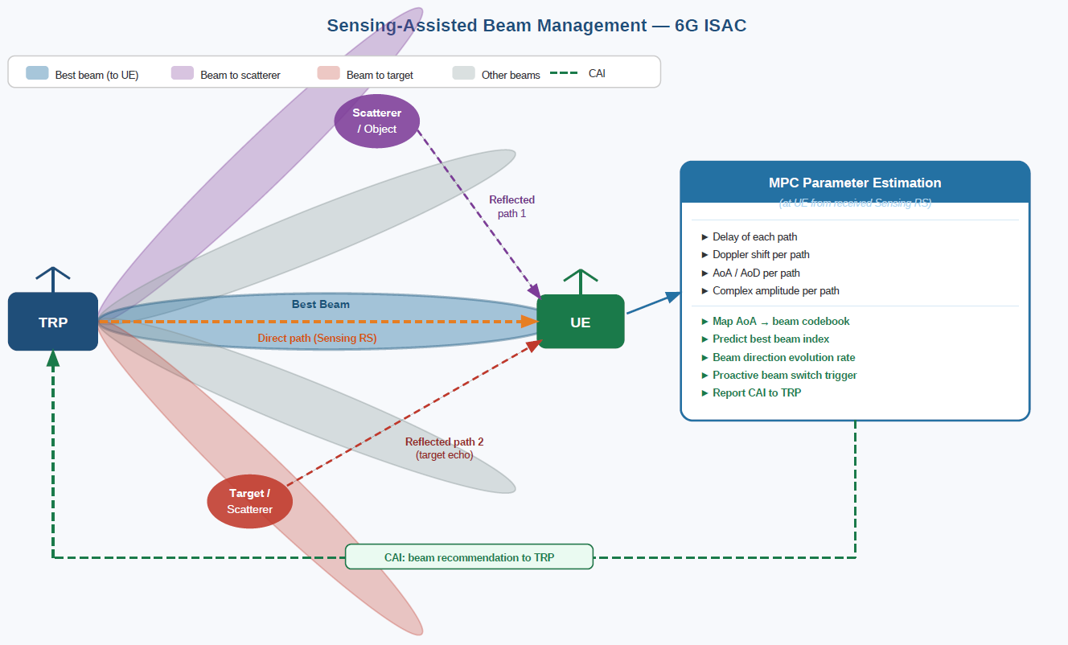

Fig 1: Sensing assisted beam management

Doppler measurements allow estimation of angular variation over time, supporting proactive beam switching rather than reactive switching triggered by RSRP degradation. In beam failure scenarios, sensing-derived angular information enables identification of a recovery beam without performing a full beam sweep.
Observation 3: Sensing-derived angular information can be used to identify dominant spatial directions, which can be mapped to candidate beams in the beam codebook, enabling: reduction of beam search space, direct identification of best beam, and tracking of beam direction evolution.
Observation 4: Sensing-derived Doppler and angular evolution enable prediction of beam dynamics over time, allowing proactive beam switching and beam failure recovery, instead of reactive mechanisms based on signal strength degradation.
Observation 5: Sensing-derived multipath component parameters provide a parametric representation of the channel, which can be used to reconstruct or predict the communication channel in time and frequency.

Mobility management
Mobility-related parameters can be derived by observing the temporal evolution of sensing measurements across multiple CPIs and a representative mapping is shown in figure 2:
- UE velocity magnitude: From Doppler shift
- UE movement direction: From joint Doppler sign and AoA/AoD evolution over time.
- Predicted UE trajectory: Obtained by tracking angular and Doppler changes across CPIs, enabling extrapolation of UE movement relative to cell geometry.
- Future link quality trend: Path power evolution provides an early indicator of approaching cell edge or blockage events, before RSRP thresholds are crossed.

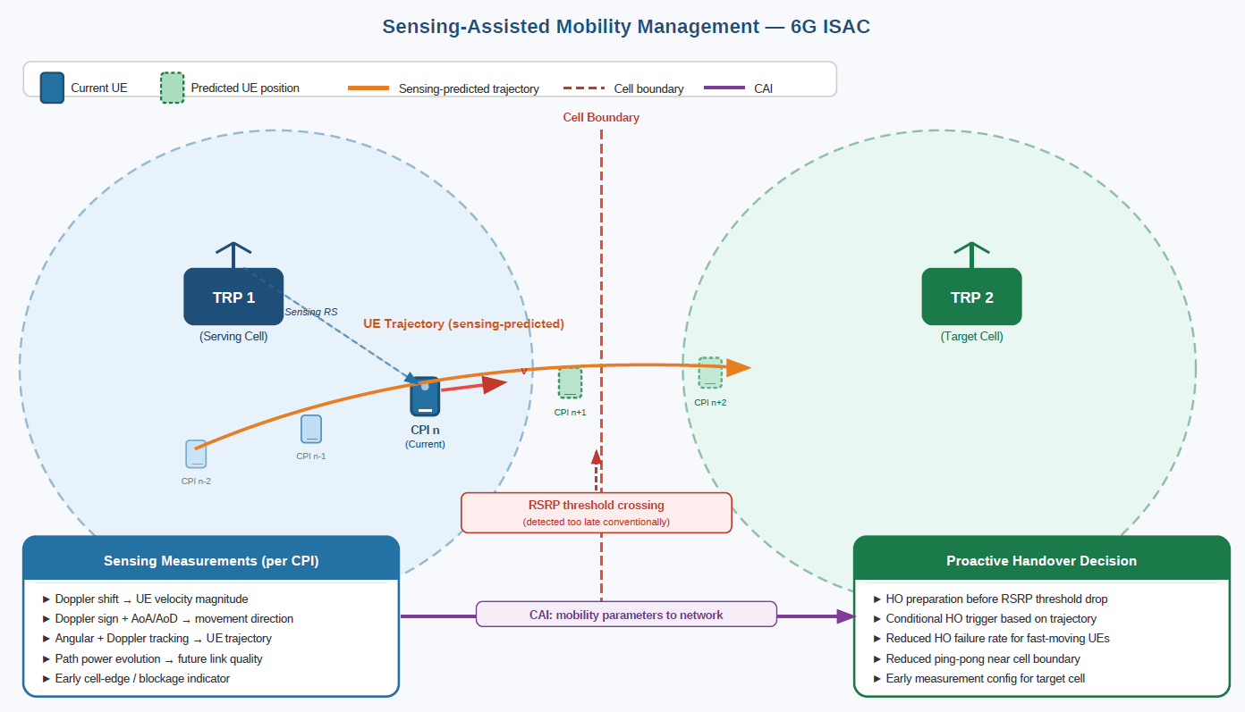
Fig 2: Sensing assisted mobility management
These derived quantities enable proactive handover preparation, allowing the network to initiate measurement configuration or conditional handover well before link quality degradation becomes observable through conventional measurements.
Observation 6: Based on sensing-derived channel representation, it is possible to reconstruct or predict channel response. This supports CSI feedback and Doppler-based channel evolution prediction, mitigating CSI aging effects, particularly for high-mobility UEs.

CSI Acquisition
CSI feedback accuracy may degrade due to channel aging, particularly for high-mobility UEs, where the channel state at the time of CSI application differs from that at the time of estimation. Sensing-derived multipath component (MPC) parameters form a parametric representation of the radio channel. Based on this representation, the communication channel can be reconstructed or predicted in an implementation-specific manner. Using the sensing-based parametric channel model, the following communication-relevant CSI information can be derived, and a representative mapping is shown in figure 3:
- Reconstructed or predicted wideband channel response, obtained by superposition of the dominant sensed paths across frequency and time
- Compressed CSI feedback, where a limited set of dominant path parameters is reported instead of wideband PMI/CQI
- Time-aligned CSI for high-mobility scenarios, enabled by Doppler-based channel evolution prediction that compensates for CSI feedback latency and channel aging
These capabilities allow sensing assisted CSI acquisition to reduce CSI-RS overhead, improve CSI timeliness, and enhance link adaptation performance, especially for UEs experiencing fast channel variation.
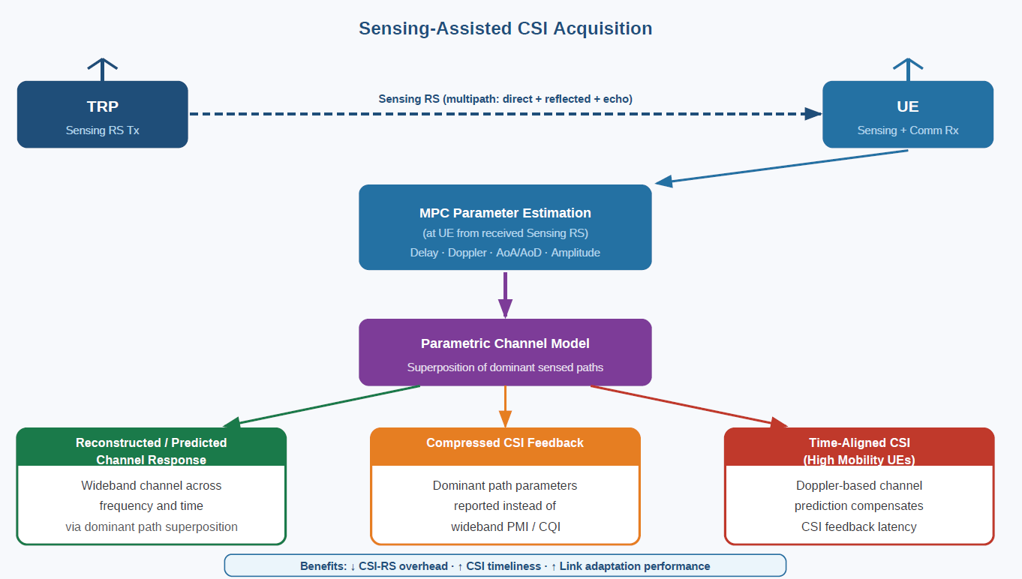
Fig 3: sensing assisted CQI acquisition
Observation 7: Temporal evolution of sensing measurements across multiple coherent processing intervals enables derivation of mobility-related information such as UE velocity, movement direction, and trajectory trends. These quantities can provide early indicators of impending cell boundary crossing or coverage degradation, well before conventional RSRP-based handover triggers are satisfied.
Proposal 2: We propose to study and define use-case-specific measurement levels and their mapping to sensing measurements. The study should include identifying:
- Which level of sensing measurement is sufficient for each use case (e.g., Level B or Level A sensing measurements are sufficient for beam management to derive beam-relevant information).
- Whether multiple reporting options should be supported for each use cases, including reporting of basic raw sensing information at the identified sensing measurement level, up to fully processed information corresponding to the final assistance metric.
This enables support of multiple measurement reporting options for sensing assisted communications, allowing flexible selection based on the trade-off between reporting overhead and processing complexity.
Proposal 3: We propose to study the overhead and synchronization aspects associated with sensing assisted communication, including:
- Reporting overhead for sensing-derived communication measurements and assistance information
- Impact of sensing measurement latency on communication decisions.
- Synchronization issues
Proposal 4: We propose to study and define the assistance information required for sensing assisted communication, example aspects to be defined include:
- Validity related metrics:
  - Prediction horizon: how far ahead the sensing-based prediction is valid.
  - Validity window: the duration for which the predicted assistance information remains applicable
- Confidence metrics:
  - Reliability or confidence level of sensing assistance communication information.

Measurement/report
- Measurement/report
  - Measurement definitions/levels for TRP-side and UE-side measurements, taking into account the impact of non-ideal factors.
  - Views on key issues of measurement reporting mechanisms.

Agreement:
- On measurement report for ISAC, study at least the following aspects and applicable scenarios (e.g., sensing modes, targets, etc.) from RAN1 perspective.
  - Measurement reporting mechanism from UE
    - Option 1A: The UE measurements and/or assistance information if needed from UE can be directly sent to aNB
    - Option 1B: The UE measurements and/or assistance information if needed from UE can be sent to SF
  - Measurement reporting mechanism from aNB
    - Option 2A: The aNB measurements and/or assistance information if needed from aNB can be directly sent to UE
    - Option 2B: The aNB measurements and/or assistance information if needed from aNB can be sent to SF
  - The study may require cross-WG coordination.

For 6G, the sensing measurement levels introduced in 5G NR can be considered a suitable starting point for both TRP-side and UE-side sensing measurements. However, refinements are required to address

UE processing complexity and to support a broader set of sensing use cases as well as sensing assisted communication use cases. In particular, for UE-side sensing and reporting, direct reporting of raw-level sensing information may not be desirable due to the associated processing complexity, power consumption, and uplink overhead.
Observation 8: The sensing measurement levels defined in 5G NR can be used as a starting point for both TRP-side and UE-side sensing in 6G.
Observation 9: Refinements of sensing measurement levels are required in 6G to:
- support to sensing and sensing-assisted communication use cases,
- address UE-side constraints such as processing complexity, power consumption, and uplink overhead.
Observation 10: For UE-side sensing and reporting, direct reporting of raw-level (level – A) sensing information is not be desirable due to processing complexity, power consumption, and uplink signaling overhead.
Proposal 5: We propose to consider the sensing measurement levels defined in 5G NR as a starting point for sensing measurement definition in 6G, applicable to both TRP-side and UE-side sensing measurements.
Proposal 6: For UE-side sensing and reporting, we propose to avoid direct reporting of raw sensing measurements (Level A), in order to limit UE processing complexity, power consumption, and uplink signaling overhead.

2.2.1 Measurement/report for sensing assisted communication
Different sensing assisted communication use cases require different sensing measurement levels. Therefore, for sensing assisted communication, it is necessary to study whether a single common reporting level, derived from sensing measurement levels defined for sensing applications, is sufficient, or whether use-case-specific reporting levels should be defined. This includes studying whether communication assistance measurement levels should be derived from an appropriate sensing measurement level and reported accordingly. For sensing-assisted communication, the measurement reporting architecture is not yet clear from a RAN1 perspective. In particular, it is unclear whether sensing measurements or sensing-derived assistance information should be reported directly to the serving aNB/TRP for timely PHY-layer communication assistance, or to a Sensing Function (SF) for further processing or coordination as given in figure 4. Similarly, measurements generated at the aNB.
Network/TRP
UE/TRP
Sensing Receiver
SF
Option A: report to TRP
Option B: report to SF

Fig 4: Measurement reporting for sensing assisted communication use case

Observation 11: Different sensing-assisted communication use cases require different sensing measurement levels, and it is unclear whether:
- a single common reporting level is sufficient, or
- use-case-specific reporting levels are needed.
For sensing assisted communication, communication assistance measurement levels may need to be derived from appropriate sensing measurement levels, depending on the use case.
Observation 12: For sensing-assisted communication, it is unclear whether sensing measurements or sensing-derived assistance information should be reported to the aNB/TRP or to a Sensing Function (SF).
Proposal 7: We propose that the definition of sensing measurement levels should explicitly consider the requirements of both sensing applications and sensing assisted communication use cases. We propose to study and define how sensing measurements should be reported for sensing assisted communication, including:
- Whether a single common reporting level, derived from sensing measurement levels defined for sensing applications, is sufficient; or
- Whether use-case-specific reporting levels are needed.
- For use-case-specific reporting levels, we further propose to study different communication assistance measurement levels required to be derived from appropriate sensing measurement levels and reported accordingly.
Proposal 8: It is proposed to study the measurement reporting architecture for sensing-assisted communication from a RAN1 perspective, including whether measurements and sensing-derived assistance information should be reported to the aNB/TRP or to a Sensing Function (SF).

2.2.2 Measurement report
Frequent and fine-granularity reporting improves sensing accuracy and the timeliness of derived communication assistance information but increases signaling overhead and resource consumption on both uplink and downlink. Conversely, restricting reporting frequency or granularity reduces overhead but may degrade sensing performance or result in stale sensing information, reducing the effectiveness of sensing assisted communication. This fundamental trade-off between reporting overhead and sensing performance requires careful consideration. One of the key issues to be addressed is the configuration of sensing and reporting periodicity based on the target use case. Applications requiring fast reaction or high prediction accuracy may necessitate frequent transmission of sensing reference signals and frequent reporting of sensing measurements, which increases overhead. In contrast, applications operating under slowly varying conditions may tolerate longer sensing and reporting periodicities, or rely on event-triggered reporting, enabling significant overhead reduction. Accordingly, it is necessary to study whether the periodicity of sensing measurements and the periodicity of sensing measurement reporting should be jointly or independently configurable, and how these configurations can be adapted per use case.

Observation 13: There exists a fundamental trade-off between sensing reporting frequency and granularity versus signaling overhead and resource consumption on uplink and downlink. Sensing and reporting periodicity requirements vary across sensing and sensing assisted communication use cases, depending on accuracy and timeliness requirements. Some applications may require frequent sensing reference signal transmission and frequent reporting to support fast reaction or high prediction accuracy, while others may tolerate longer periodicities or event-triggered reporting.
Observation 14: It is necessary to study whether the periodicity of sensing reference signals and sensing measurement reporting should be jointly configurable or independently configurable on a per-use-case basis.
Proposal 9: We propose to study the configuration of sensing measuremnts and reporting periodicity for different sensing and sensing assisted communication use cases, which impose different requirements in terms of sensing accuracy, timeliness, and prediction horizon. This includes studying whether the periodicity of sensing reference signals and sensing measurement reporting should be jointly or independently configurable on a per-use-case basis.

2.2.3 Non-ideal factors
Another key issue is the handling of synchronization aspects, particularly in bistatic or multi-static sensing configurations, where sensing transmission and reception occur at different nodes especially when one of the transmitting or receiving node is a UE. Time and frequency synchronization errors directly impact sensing measurement accuracy and the validity of derived communication assistance information. For UE-side sensing and reporting, overhead reduction mechanisms are especially critical due to limited uplink resources and UE power constraints. Efficient approaches such as measurement compression, selective reporting, and reporting of only significant changes should be considered to minimize reporting overhead while maintaining sufficient sensing fidelity for the intended application.

Observation 15: Synchronization aspects are a key consideration for sensing measurement reporting, particularly in bistatic and multi-static sensing configurations, where time and frequency synchronization errors impact sensing accuracy and the validity of derived communication assistance information.
Observation 16: For UE-side reporting, overhead reduction mechanisms such as measurement compression, selective reporting, and reporting of significant changes are important due to uplink resource limitations and UE power constraints.
Proposal 10: We propose to study synchronization aspects affecting sensing measurement reporting, particularly for bistatic and multi-static sensing configurations, where sensing transmission and reception occur at different nodes especially when one of the transmitting or receiving node is a UE.
Proposal 11: For UE-side sensing and reporting, we propose to study overhead reduction mechanisms, including but not limited to:
- Measurement compression
- Selective reporting
- Reporting of significant changes only
with the objective of minimizing uplink signaling overhead while maintaining sufficient sensing fidelity for the intended sensing or sensing assisted communication use case.

RS design
- RS design
  - Please elaborate designs on sensing RS especially the RE patterns.
  - Please provide evaluations/analysis.

On sensing reference signal design for ISAC, it is important to evaluate the suitability of existing RS in terms of resource-element (RE) patterns, time-frequency density, spatial coverage, and periodicity, and to assess their achievable sensing performance together with their impact on communication operation. Such evaluation and analysis can help identify potential limitations, including insufficient delay-Doppler resolution, spatial coverage constraints, or coexistence impact, and determine whether existing communication RS can adequately support sensing and sensing-assisted communication use cases, or whether additional sensing-specific RS enhancements or new RS designs are required.
Observation 17: Existing communication reference signals can be considered as candidate signals for ISAC, but their suitability for sensing depends on factors such as RE patterns, time-frequency density, spatial coverage, and their impact on communication, which need to be evaluated.
Proposal 12: It is proposed to wait until the RS discussion for 6G under agenda item 10.5.3 is completed before discussing new sensing RS design, or we propose to reuse of existing communication RS as a baseline for ISAC, with evaluation of their RE patterns and sensing performance to identify any gaps or need for enhancement.

Resource allocation/multiplexing

[FL1][H] Proposal 4.3-1-rev1
- On resource multiplexing between within sensing signals or between sensing and communication, study at least the following aspects.
  - TDM, FDM, CDM, SDM or using data in communication channel for sensing
  - Impact of BWP
  - Impact of measurement gap or sensing processing window
  - PDSCH DL rate matching around sensing RS resources
  - PUSCH UL muting around sensing RS resources
  - Collison handling between sensing and communication
  - Other aspects are not precluded

The configuration of sensing operations plays a critical role in integrated sensing and communication. Sensing performance and associated overhead depend on how sensing reference signal transmission, sensing processing windows, and sensing measurement extraction are configured. These aspects are inherently depend on use-case, and mode of operation (TRP-TRP, TRP-UE, or UE-TRP). Some sensing use cases require frequent sensing operation and low processing latency, while others can tolerate infrequent sensing, longer processing intervals, or event-triggered sensing operation.
Observation 18: The configuration of sensing reference signal density, and sensing processing windows, is use-case dependent, with different sensing use cases requiring different sensing periodicity and sensing RS density.
Proposal 13: We propose to study use-case-dependent configuration for multiplexing schemes, including sensing reference signal density, and sensing processing window.
Proposal 14: We propose to study whether sensing operations should be configured as periodic, semi-periodic, or event-triggered, depending on the use case, to balance sensing and communication performance, and signaling overhead.

Interference handling

[FL1][H] Proposal 4.7-1
- On interference handling for ISAC, study at least the following aspects, to mitigate the interference between sensing signals and between sensing and communication.
  - Transmitter-side interference avoidance/coordination
  - Receiver-side interference cancellation
  - Interference measurement/report
    - Interference resource/report configuration
    - Interference measurement quantities
    - Interference measurement report
  - Other solutions for interference handling are not precluded

We agree with the proposal that transmitter-side interference avoidance/coordination, receiver-side interference cancellation, and interference measurement and reporting should be studied to mitigate interference between sensing signals and between sensing and communication signals in ISAC. We consider it important to study interference measurement and reporting mechanisms as a foundational enabler for effective interference handling in ISAC. Since interference between sensing signals and between sensing and communication signals can vary significantly across time, frequency, and spatial, interference handling mechanisms require accurate and timely visibility of the interference conditions. This necessitates studying how interference measurements are configured, including the selection of measurement resources and occasions that allow reliable characterization of interference without contamination from desired sensing or communication signals.
Furthermore, the definition of interference measurement quantities needs to reflect the characteristics of ISAC operation and the intended interference handling objectives. In addition to scalar quantities such as interference power or interference-to-noise ratio, ISAC may require richer interference representations, such as spatial interference characteristics or delay-Doppler-domain interference information for sensing receivers. These measurements provide essential information for transmitter-side coordination (e.g., beam or resource adaptation) as well as receiver-side interference suppression or cancellation. It should also be noted that interference measurements are themselves subject to non-ideal factors such as timing synchronization error and phase noise, which can cause the measured interference to differ from the actual interference experienced during sensing operation. The interference measurement resource configuration should therefore account for these non-ideal effects to ensure reliable interference characterization.
The design of interference measurement reporting mechanisms is also a key aspect. This includes specifying what interference information is reported, to which network or sensing entity it is delivered, and with what reporting granularity and latency. Reporting may need to be periodic, or aperiodic, or triggered based on interference dynamics and use-case requirements. At the same time, reporting overhead and UE capability constraints must be carefully considered, particularly when reporting higher-dimensional information such as spatial or delay-Doppler interference representations. Therefore, efficient reporting formats and possible compression mechanisms should be studied to balance reporting efficiency with the fidelity needed for effective interference handling.

Observation 19: Effective interference handling in ISAC depends on the availability of accurate and timely interference measurement and reporting, which enables adaptive coordination, avoidance, and cancellation techniques.
Observation 20: Interference characteristics can vary across time, frequency, and spatial domains, indicating that interference conditions cannot be sufficiently characterized by a single aggregated metric.
Observation 21: Interference measurement quantities for ISAC may need to extend beyond conventional scalar metrics (e.g., interference power or INR) to include spatial interference characteristics and delay-Doppler-domain interference information, particularly for sensing receivers.
Observation 22: The interference measurements are subject to non-ideal factors, which can cause the measured interference to differ from the actual interference experienced. The interference measurement resource configuration should account for these effects to ensure reliable interference characterization.
Observation 23: The interference measurement reporting design needs to specify what interference information is reported, to which network or sensing entity or sensing function is delivered, and with what granularity and latency, with reporting triggered periodically, aperiodically, or based on interference dynamics and use-case requirements.
Observation 24: Reporting overhead and UE capability constraints are critical considerations for interference measurement reporting, particularly when reporting higher-dimensional spatial or delay-Doppler interference representations. Efficient reporting formats and compression or abstraction mechanisms are needed to balance reporting efficiency with the fidelity required for effective interference handling.
Proposal 15: It is proposed to deprioritize detailed interference handling solutions at this stage, as these are largely proprietary and implementation-specific.
Proposal 16: It is further proposed to study ISAC-specific interference measurement quantities, beyond conventional scalar metrics, to support spatial-domain and sensing-oriented interference characterization where needed.
Proposal 17: In addition, the impact of non-ideal effects (e.g., synchronization errors and phase noise) on interference measurement accuracy should be studied, including how these effects are accounted for in interference measurement design.
Proposal 18: Finally, efficient interference reporting mechanisms should be studied, including reporting granularity, triggering conditions, and compression techniques, to balance reporting overhead, particularly for UE-side reporting.

Power control

[FL1][H] Proposal 4.8-1-rev1
- On power control for ISAC, study at least the following aspects, considering both sensing performance and impacts to communication.
  - P0/alpha
  - Pathloss reference
  - CL PC
  - PHR
  - DL PC
  - Impact to phase continuity within CPI

We agree with the proposal to study power control for ISAC, as power control directly affects sensing performance as well as communication performance. In particular, it should be clarified whether the proposed study considers uplink power control and downlink power control/power allocation jointly or separately, given their different mechanisms and constraints. It should also be clarified whether the intent is to study sensing-specific power control mechanisms, or power control mechanisms that are jointly applicable to sensing and communication. In addition, since power control directly influences interference characteristics in ISAC, the study should consider how power control settings impact mutual interference between sensing and communication transmissions.
Observation 25: Power control has a direct impact on both sensing performance and communication performance in ISAC.
Observation 26: There is ambiguity on whether power control for ISAC is intended to be studied jointly or separately for uplink and downlink, given their different mechanisms and constraints.
Observation 27: It is unclear whether power control mechanisms under study are sensing-specific or jointly applicable to sensing and communication, indicating a need for clarification of study scope.
Observation 28: Power control settings directly influence mutual interference between sensing and communication transmissions, and this interaction needs to be considered in the ISAC context.
Proposal 19: We propose to deprioritize detailed power-control solution discussion at this stage
Proposal 20: It is further proposed to clarify in the proposal whether uplink power control and downlink power control/power allocation for ISAC should be addressed jointly or separately, given their different mechanisms and constraints.
Proposal 21: In addition, it is proposed to clarify in the proposal whether power control mechanisms for ISAC should be sensing-specific or jointly applicable to sensing and communication.
Proposal 22: The impact of power control on interference between sensing and communication transmissions should be studied.

Phase continuity within a CPI
- On phase continuity for DL/UL sensing RS, study at least the following aspects.
  - Aspects to maintain phase continuity in a CPI
  - Events causing phase discontinuity, e.g., TDD UL/DL switch, change of power/TA, etc.
  - Whether/how to recover phase continuity?
  - Other aspects are not precluded

We agree with the proposal to study phase continuity for DL/UL sensing reference signals. Phase continuity within a CPI can be disrupted by various PHY and system-level events. In addition to power control or power changes, timing advance updates and TDD UL/DL switching, such events include beam switching or beam management procedures occurring during a CPI, frequency hopping or frequency correction updates, and hardware or system-related causes such as RF chain reconfiguration. Identifying these events is essential to understand when and why phase discontinuity may occur during sensing operation.
Observation 29: In addition to power control or power changes and TDD UL/DL switching, events such as timing advance updates, beam switching or beam management during a CPI, frequency hopping or frequency correction updates, and hardware or system-related causes (e.g., RF chain reconfiguration) can introduce phase discontinuity.
Proposal 23: We propose to deprioritize detailed phase continuity solution discussion at this stage.
Proposal 24: In addition, it is proposed to identify and categorize PHY- and system-level events that can cause phase discontinuity within a CPI, and to study their impact and possible mitigation aspects.

Timing advance
Timing advance (TA) introduces several ISAC-specific considerations. In NR, TA compensates the one-way UE-to-gNB propagation delay for uplink alignment and the assumptions underlying communication TA are not directly applicable to ISAC sensing operations. In sensing, the received sensing signal is associated with a two-way propagation path involving the sensing transmitter, the target, and the sensing receiver, and therefore the timing relationship differs from conventional uplink communication. Applying communication TA directly to sensing reference signals may shift the sensing timing reference and introduce systematic bias in range estimation. The issue becomes more challenging in bistatic and multi-static sensing scenarios, where sensing transmission and reception occur at different nodes with different timing references and propagation delays. In such cases, synchronization and timing alignment between sensing transmitters and receivers become critical for accurate sensing operation. Furthermore, in multi-static sensing with multiple receiving nodes, node-specific timing relationships may be required, which cannot be fully addressed by the single TA mechanism currently defined for communication systems. Another important aspect is that TA updates during a CPI may introduce phase discontinuities, which can degrade Doppler estimation and sensing coherence.
Observation 30: Applying communication-oriented TA directly to sensing reference signals may shift the sensing timing reference and introduce systematic bias in sensing range estimation.
Observation 31: In bistatic and multi-static sensing scenarios, sensing transmission and reception occur at different nodes with independent timing references and propagation delays, making synchronization and timing alignment more challenging than in conventional uplink communication.
Observation 32: TA updates occurring within a CPI may introduce timing and phase discontinuities, which can degrade coherent sensing processing such as Doppler estimation.
Proposal 25: We propose to deprioritize TA discussion for ISAC at this stage.

Proposal and Observations
We list all the observations and proposals here for quick reference.

Proposals
Proposal 1: On sensing-assisted communication, it is proposed to consider the following use cases as initial study items, with discussion prioritize in the following order:
- Beam management
- Mobility management
- CSI acquisition
Proposal 2: We propose to study and define use-case-specific measurement levels and their mapping to sensing measurements. The study should include identifying:
- Which level of sensing measurement is sufficient for each use case (e.g., Level B or Level A sensing measurements are sufficient for beam management to derive beam-relevant information).
- Whether multiple reporting options should be supported for each use cases, including reporting of basic raw sensing information at the identified sensing measurement level, up to fully processed information corresponding to the final assistance metric.
This enables support of multiple measurement reporting options for sensing assisted communications, allowing flexible selection based on the trade-off between reporting overhead and processing complexity.
Proposal 3: We propose to study the overhead and synchronization aspects associated with sensing assisted communication, including:
- Reporting overhead for sensing-derived communication measurements and assistance information
- Impact of sensing measurement latency on communication decisions.
- Synchronization issues
Proposal 4: We propose to study and define the assistance information required for sensing assisted communication, example aspects to be defined include:
- Validity related metrics:
  - Prediction horizon: how far ahead the sensing-based prediction is valid.
  - Validity window: the duration for which the predicted assistance information remains applicable
- Confidence metrics:
  - Reliability or confidence level of sensing assistance communication information.
Proposal 5: We propose to consider the sensing measurement levels defined in 5G NR as a starting point for sensing measurement definition in 6G, applicable to both TRP-side and UE-side sensing measurements.
Proposal 6: For UE-side sensing and reporting, we propose to avoid direct reporting of raw sensing measurements (Level A), in order to limit UE processing complexity, power consumption, and uplink signaling overhead.
Proposal 7: We propose that the definition of sensing measurement levels should explicitly consider the requirements of both sensing applications and sensing assisted communication use cases. We propose to study and define how sensing measurements should be reported for sensing assisted communication, including:
- Whether a single common reporting level, derived from sensing measurement levels defined for sensing applications, is sufficient; or
- Whether use-case-specific reporting levels are needed.
- For use-case-specific reporting levels, we further propose to study different communication assistance measurement levels required to be derived from appropriate sensing measurement levels and reported accordingly.
Proposal 8: It is proposed to study the measurement reporting architecture for sensing-assisted communication from a RAN1 perspective, including whether measurements and sensing-derived assistance information should be reported to the aNB/TRP or to a Sensing Function (SF).
Proposal 9: We propose to study the configuration of sensing measuremnts and reporting periodicity for different sensing and sensing assisted communication use cases, which impose different requirements in terms of sensing accuracy, timeliness, and prediction horizon. This includes studying whether the periodicity of sensing reference signals and sensing measurement reporting should be jointly or independently configurable on a per-use-case basis.
Proposal 10: We propose to study synchronization aspects affecting sensing measurement reporting, particularly for bistatic and multi-static sensing configurations, where sensing transmission and reception occur at different nodes especially when one of the transmitting or receiving node is a UE.
Proposal 11: For UE-side sensing and reporting, we propose to study overhead reduction mechanisms, including but not limited to:
- Measurement compression
- Selective reporting
- Reporting of significant changes only
with the objective of minimizing uplink signaling overhead while maintaining sufficient sensing fidelity for the intended sensing or sensing assisted communication use case.
Proposal 12: It is proposed to wait until the RS discussion for 6G under agenda item 10.5.3 is completed before discussing new sensing RS design, or we propose to reuse of existing communication RS as a baseline for ISAC, with evaluation of their RE patterns and sensing performance to identify any gaps or need for enhancement.
Proposal 13: We propose to study use-case-dependent configuration for multiplexing schemes, including sensing reference signal density, and sensing processing window.
Proposal 14: We propose to study whether sensing operations should be configured as periodic, semi-periodic, or event-triggered, depending on the use case, to balance sensing and communication performance, and signaling overhead.
Proposal 15: It is proposed to deprioritize detailed interference handling solutions at this stage, as these are largely proprietary and implementation-specific.
Proposal 16: It is further proposed to study ISAC-specific interference measurement quantities, beyond conventional scalar metrics, to support spatial-domain and sensing-oriented interference characterization where needed.
Proposal 17: In addition, the impact of non-ideal effects (e.g., synchronization errors and phase noise) on interference measurement accuracy should be studied, including how these effects are accounted for in interference measurement design.
Proposal 18: Finally, efficient interference reporting mechanisms should be studied, including reporting granularity, triggering conditions, and compression techniques, to balance reporting overhead, particularly for UE-side reporting.
Proposal 19: We propose to deprioritize detailed power-control solution discussion at this stage
Proposal 20: It is further proposed to clarify in the proposal whether uplink power control and downlink power control/power allocation for ISAC should be addressed jointly or separately, given their different mechanisms and constraints.
Proposal 21: In addition, it is proposed to clarify in the proposal whether power control mechanisms for ISAC should be sensing-specific or jointly applicable to sensing and communication.
Proposal 22: The impact of power control on interference between sensing and communication transmissions should be studied.
Proposal 23: We propose to deprioritize detailed phase continuity solution discussion at this stage.
Proposal 24: In addition, it is proposed to identify and categorize PHY- and system-level events that can cause phase discontinuity within a CPI, and to study their impact and possible mitigation aspects.
Proposal 25: We propose to deprioritize TA discussion for ISAC at this stage.

Observations
Observation 1: Conventional communication procedures (e.g., beam management, CSI acquisition, mobility management) rely on communication-centric measurements such as RSRP, RSRQ, and CQI, which are inherently reactive, as they detect environmental changes only after communication performance degradation occurs.
Observation 2: Sensing measurements provide direct estimation of multipath propagation parameters, enabling characterization of the physical environment beyond what is available from conventional communication measurements.
Observation 3: Sensing-derived angular information can be used to identify dominant spatial directions, which can be mapped to candidate beams in the beam codebook, enabling: reduction of beam search space, direct identification of best beam, and tracking of beam direction evolution.
Observation 4: Sensing-derived Doppler and angular evolution enable prediction of beam dynamics over time, allowing proactive beam switching and beam failure recovery, instead of reactive mechanisms based on signal strength degradation.
Observation 5: Sensing-derived multipath component parameters provide a parametric representation of the channel, which can be used to reconstruct or predict the communication channel in time and frequency.
Observation 6: Based on sensing-derived channel representation, it is possible to reconstruct or predict channel response. This supports CSI feedback and Doppler-based channel evolution prediction, mitigating CSI aging effects, particularly for high-mobility UEs.
Observation 7: Temporal evolution of sensing measurements across multiple coherent processing intervals enables derivation of mobility-related information such as UE velocity, movement direction, and trajectory trends. These quantities can provide early indicators of impending cell boundary crossing or coverage degradation, well before conventional RSRP-based handover triggers are satisfied.
Observation 8: The sensing measurement levels defined in 5G NR can be used as a starting point for both TRP-side and UE-side sensing in 6G.
Observation 9: Refinements of sensing measurement levels are required in 6G to:
- support to sensing and sensing-assisted communication use cases,
- address UE-side constraints such as processing complexity, power consumption, and uplink overhead.
Observation 10: For UE-side sensing and reporting, direct reporting of raw-level (level – A) sensing information is not be desirable due to processing complexity, power consumption, and uplink signaling overhead.
Observation 11: Different sensing-assisted communication use cases require different sensing measurement levels, and it is unclear whether:
- a single common reporting level is sufficient, or
- use-case-specific reporting levels are needed.
For sensing assisted communication, communication assistance measurement levels may need to be derived from appropriate sensing measurement levels, depending on the use case.
Observation 12: For sensing-assisted communication, it is unclear whether sensing measurements or sensing-derived assistance information should be reported to the aNB/TRP or to a Sensing Function (SF).
Observation 13: There exists a fundamental trade-off between sensing reporting frequency and granularity versus signaling overhead and resource consumption on uplink and downlink. Sensing and reporting periodicity requirements vary across sensing and sensing assisted communication use cases, depending on accuracy and timeliness requirements. Some applications may require frequent sensing reference signal transmission and frequent reporting to support fast reaction or high prediction accuracy, while others may tolerate longer periodicities or event-triggered reporting.
Observation 14: It is necessary to study whether the periodicity of sensing reference signals and sensing measurement reporting should be jointly configurable or independently configurable on a per-use-case basis.
Observation 15: Synchronization aspects are a key consideration for sensing measurement reporting, particularly in bistatic and multi-static sensing configurations, where time and frequency synchronization errors impact sensing accuracy and the validity of derived communication assistance information.
Observation 16: For UE-side reporting, overhead reduction mechanisms such as measurement compression, selective reporting, and reporting of significant changes are important due to uplink resource limitations and UE power constraints.
Observation 17: Existing communication reference signals can be considered as candidate signals for ISAC, but their suitability for sensing depends on factors such as RE patterns, time-frequency density, spatial coverage, and their impact on communication, which need to be evaluated.
Observation 18: The configuration of sensing reference signal density, and sensing processing windows, is use-case dependent, with different sensing use cases requiring different sensing periodicity and sensing RS density.
Observation 19: Effective interference handling in ISAC depends on the availability of accurate and timely interference measurement and reporting, which enables adaptive coordination, avoidance, and cancellation techniques.
Observation 20: Interference characteristics can vary across time, frequency, and spatial domains, indicating that interference conditions cannot be sufficiently characterized by a single aggregated metric.
Observation 21: Interference measurement quantities for ISAC may need to extend beyond conventional scalar metrics (e.g., interference power or INR) to include spatial interference characteristics and delay-Doppler-domain interference information, particularly for sensing receivers.
Observation 22: The interference measurements are subject to non-ideal factors, which can cause the measured interference to differ from the actual interference experienced. The interference measurement resource configuration should account for these effects to ensure reliable interference characterization.
Observation 23: The interference measurement reporting design needs to specify what interference information is reported, to which network or sensing entity or sensing function is delivered, and with what granularity and latency, with reporting triggered periodically, aperiodically, or based on interference dynamics and use-case requirements.
Observation 24: Reporting overhead and UE capability constraints are critical considerations for interference measurement reporting, particularly when reporting higher-dimensional spatial or delay-Doppler interference representations. Efficient reporting formats and compression or abstraction mechanisms are needed to balance reporting efficiency with the fidelity required for effective interference handling.
Observation 25: Power control has a direct impact on both sensing performance and communication performance in ISAC.
Observation 26: There is ambiguity on whether power control for ISAC is intended to be studied jointly or separately for uplink and downlink, given their different mechanisms and constraints.
Observation 27: It is unclear whether power control mechanisms under study are sensing-specific or jointly applicable to sensing and communication, indicating a need for clarification of study scope.
Observation 28: Power control settings directly influence mutual interference between sensing and communication transmissions, and this interaction needs to be considered in the ISAC context.
Observation 29: In addition to power control or power changes and TDD UL/DL switching, events such as timing advance updates, beam switching or beam management during a CPI, frequency hopping or frequency correction updates, and hardware or system-related causes (e.g., RF chain reconfiguration) can introduce phase discontinuity.
Observation 30: Applying communication-oriented TA directly to sensing reference signals may shift the sensing timing reference and introduce systematic bias in sensing range estimation.
Observation 31: In bistatic and multi-static sensing scenarios, sensing transmission and reception occur at different nodes with independent timing references and propagation delays, making synchronization and timing alignment more challenging than in conventional uplink communication.
Observation 32: TA updates occurring within a CPI may introduce timing and phase discontinuities, which can degrade coherent sensing processing such as Doppler estimation.

References
- 3GPP TR 38.914, Study on 6G Scenarios and Requirements.
- 3GPP TR 38.765, Study on Integrated Sensing and Communication (ISAC) for NR.
- 3GPP TS 38.211, NR; Physical channels and modulation.
- 3GPP TS 38.214, NR; Physical layer procedures for data.
- R1-2602592, Summary #4 on integration with communication for ISAC

